How to Access Opposing Viewpoints
May 14, 2010

Questions? Ask Jennifer Maurer, School Library Consultant at the State Library.
jennifer.maurer@state.or.us or 503.378.5011
(Don’t see the purple indicator arrows? Try clicking on Print Preview.)

Option 1
Go to www.oslis.org.
Click on Secondary Student (or Secondary Educator).
Click on Find Information.
Opposing Viewpoints is the middle choice in the top row.

http://secondary.oslis.org/find-information

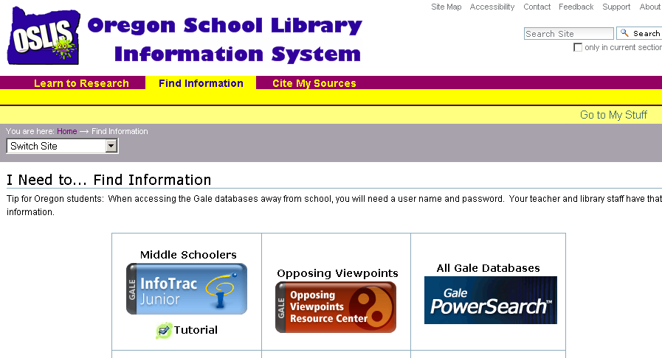

Scroll for Option 2.

Also, check out the OVRC training resources on the Gale support site. Go to http://galesupport.com/oregon/ and click on this image:
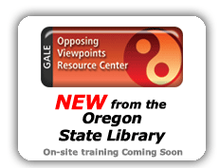.
Option 2

Go to www.oslis.org.
Choose any of the 4 skins (Elementary Student, Secondary Educator, etc.).
Click on Find Information.
Choose any of the Gale databases or the PowerSearch interface.
If you choose PowerSearch, you can skip the “Change Databases” step.
Log in, if necessary.
Click on Change Databases, found in the toolbar at the top of the screen.
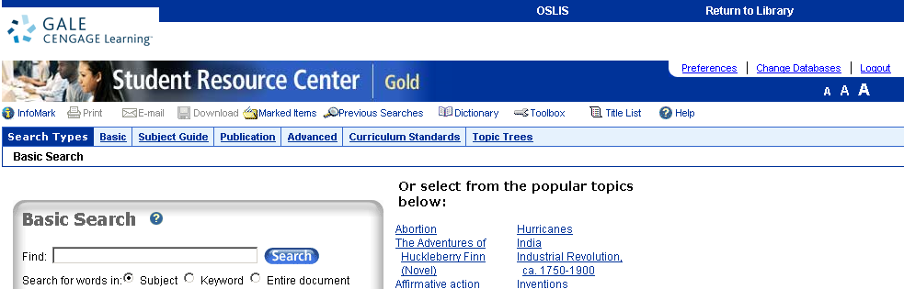

Click on Opposing Viewpoints, which should be the 6th choice in the common menu that pops up.
