How to Access AP Practice Tests on LearningExpress Library
- Go to the Secondary Student Find Information page on OSLIS: http://secondary.oslis.org/find-information. (Or, go to www.oslis.org, click on Secondary Student, and then click on Find Information.)
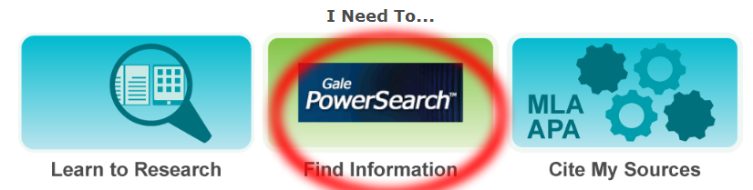
- Click on LearningExpress, the light bulb logo.
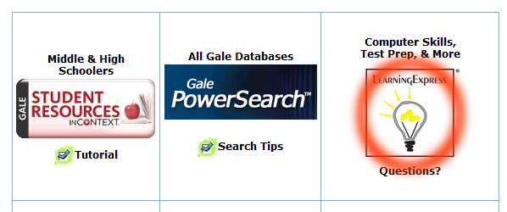
- Fill in your username and password in the boxes at the bottom right corner of the screen, and then click on Login. (Or, click on Login at the top and then fill in the fields.)
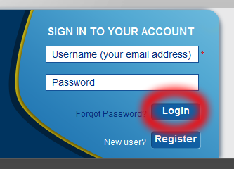
- If you have not registered for an account yet, click on New user? Register in the bottom right corner. Fill out the form and click on Create Account. If you do not have an email address, see 4b below. Note: The email address you enter will become your username. Then go back to step 3.
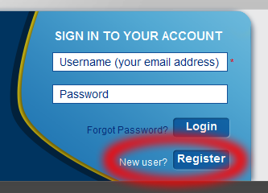 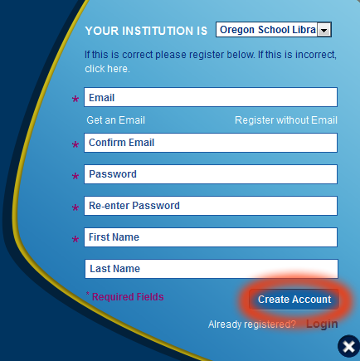
Only if you do not have an email address and need to register for an account, start by clicking
on Register without Email. That will lead to a different form. Click Create Account when done
filling out the form. Then go back to step 3.
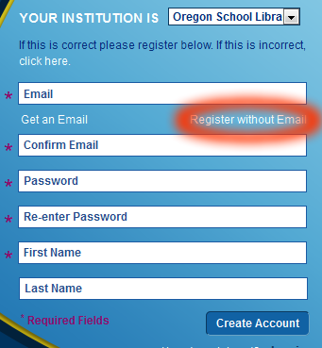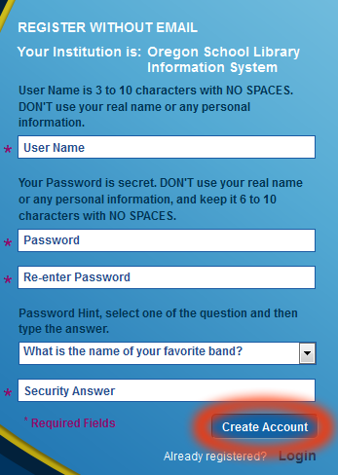
- Once you are logged in, scroll through the Center choices by clicking on the right arrow. Stop when you get to College Prep Center. Click on that. (Or, click on All Centers in the top left of the page, and then click on College Prep Center.)
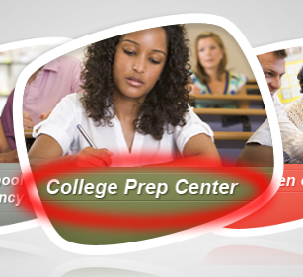
- Click on Prepare for Your AP Exam.
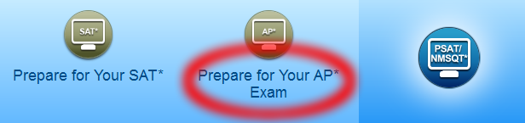
- Pay attention to options in the heading at the top of the page and those in the left navigation. For example, the page will open to the practice tests available for AP calculus. Click on other test subjects or on eBooks to see more options.
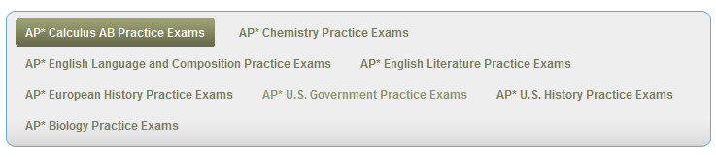
and
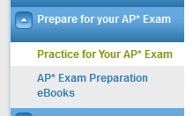
- After selecting the test or eBook you want, click on its title or on the Launch button.
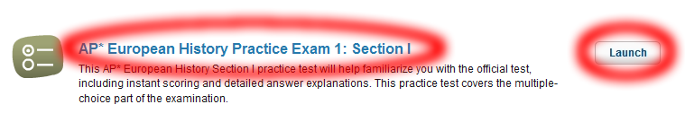
- Read the instructions on the page, and for a test, choose the mode you want to try: Simulation, Practice, or Learner. Then click on Start Test.
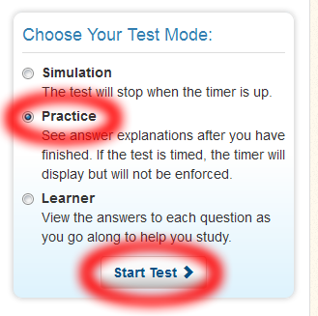
- When you are ready to stop, choose from one of these options at the top right of the page: Save and Finish Later (if not done with the test or not ready to score it) or Score My Test. Then log out using the options at the top or bottom right of the page.
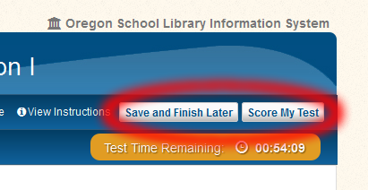

- To access a saved resource later, log in and then click on My Center in the top right corner.
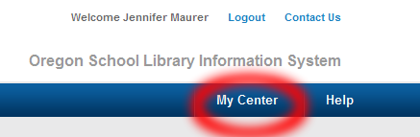
- Click on the plus sign by the name of the resource you want to access. (It will change to a minus sign after you click on it.) Click on Resume Test to pick up where you left off.
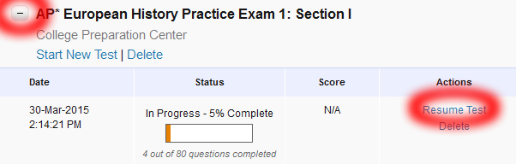

Questions? Contact __________________________________.

