11/21/14
Finding Content from Specific Publications (Books or Magazines) in Kids InfoBits

- From www.oslis.org, click on Elementary Student and then on Find Information.

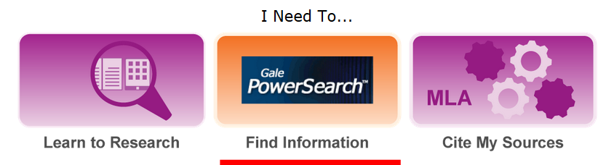

- Click on Kids InfoBits. Enter your Gale login information if prompted.

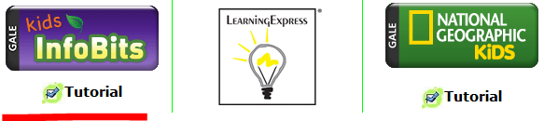

- From the Kids InfoBits homepage, click on Advanced Search in the green bar at the top.

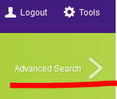

- Click on the arrow next to Keyword, and choose Publication Title from the down-down menu.

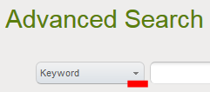 Change to 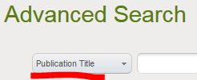

- Type the name of the book or magazine you want to find, and click on Search.
(Hint: Check the Gale title lists to know which publications feed into Kids InfoBits. The lists are available here, http://solutions.cengage.com/Gale/Database-Title-Lists/, and from the Tools menu at the top of any Kids InfoBits page.)

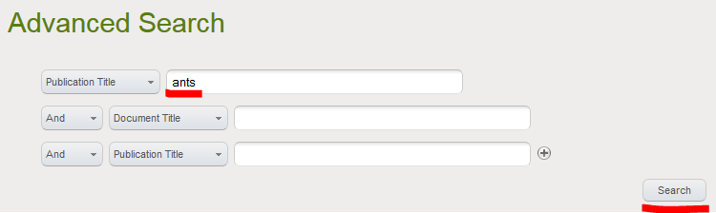
- Click on View All to see all of the content available from that publication.

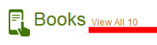
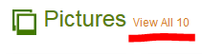
- To quickly access all content from one book or magazine, click on Bookmark in the top right corner of the page, and save the URL. (Do this after clicking on View All.) You can add the URL to an assignment sheet, email it to yourself, etc.
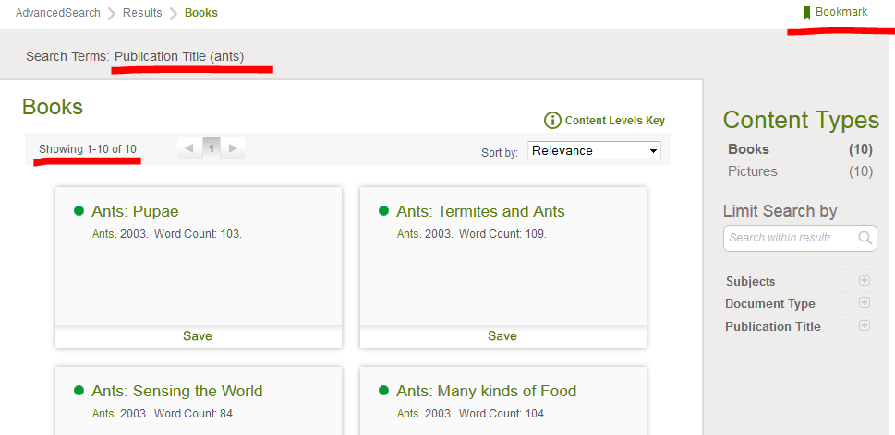

Here is an example of the article called Larvae from the Ants book. You can access that content by clicking on this Bookmark:
http://go.galegroup.com/ps/i.do?id=GALE%7CLYNQSC281453124&v=2.1&u=oslis&it=r&p=ITKE&sw=w&asid=31f7dcd18b6618a610f4ebc6e89528f3
If prompted to log in, use your Gale username and password. If there is just one text box, use the password.

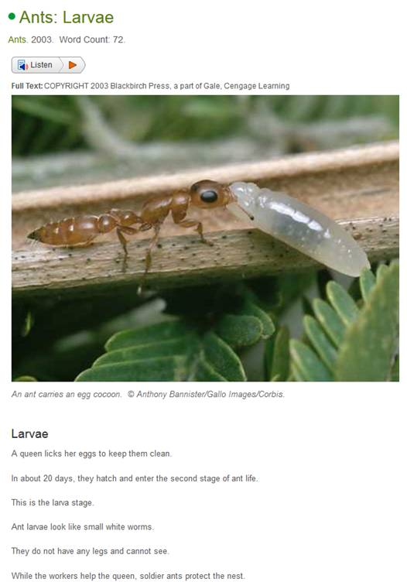
This is the Bookmark that leads to all of the articles from Ants:
http://go.galegroup.com/ps/i.do?ty=as&v=2.1&u=oslis&it=search&s=RELEVANCE-SORT&p=ITKE&st=T001&dblist=ITKE&qt=PU~ants&sw=w&asid=387f669bee66376339878c3aa941ec38

Questions? Contact Jennifer Maurer, School Library Consultant, Oregon State Library
jennifer.maurer@state.or.us –or– 503.378.5011

